Documentation Guide

* Launch chrome

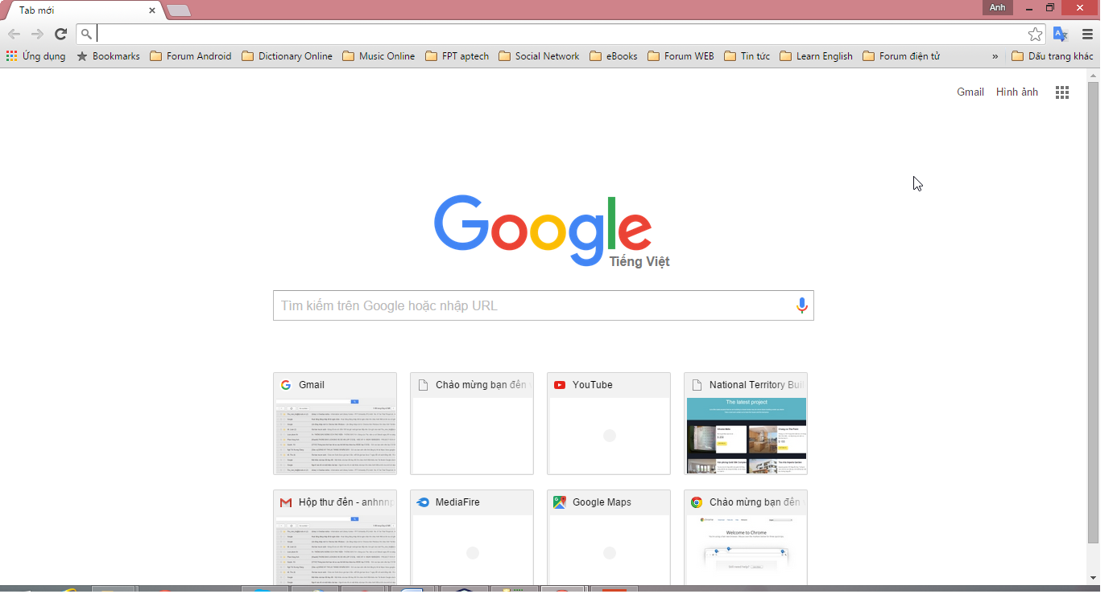

* Typing in the browser address bar the following address: [***http://localhost:8080/source_code***](http://localhost:8080/source_code)

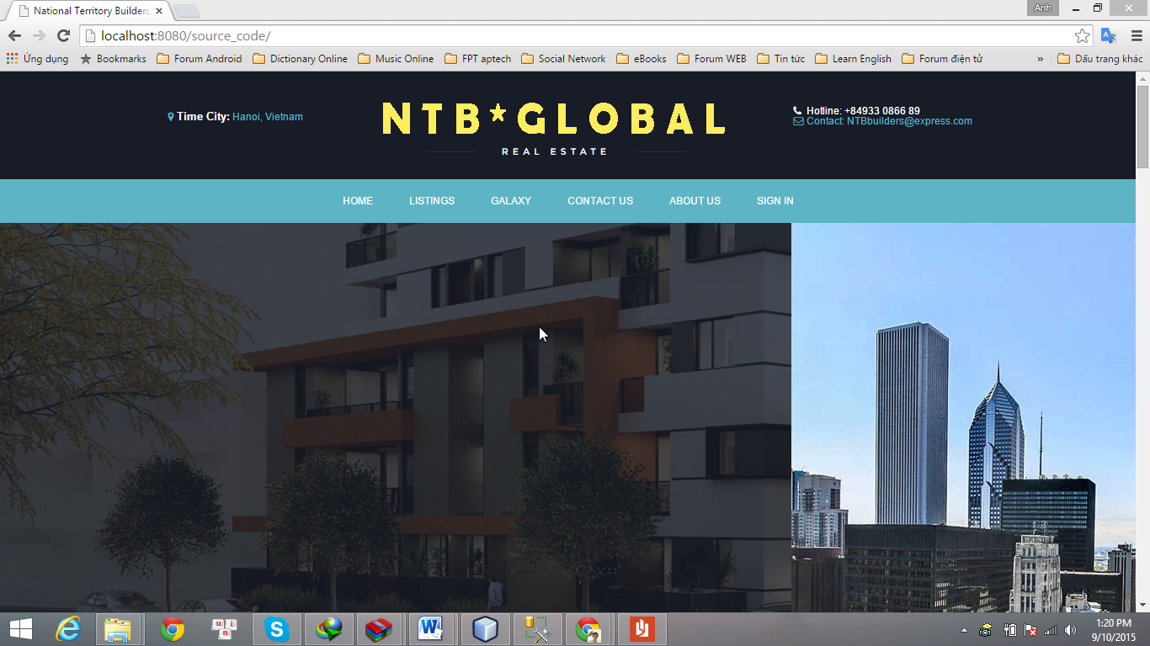

* Click menu SIGN IN: Account Admin

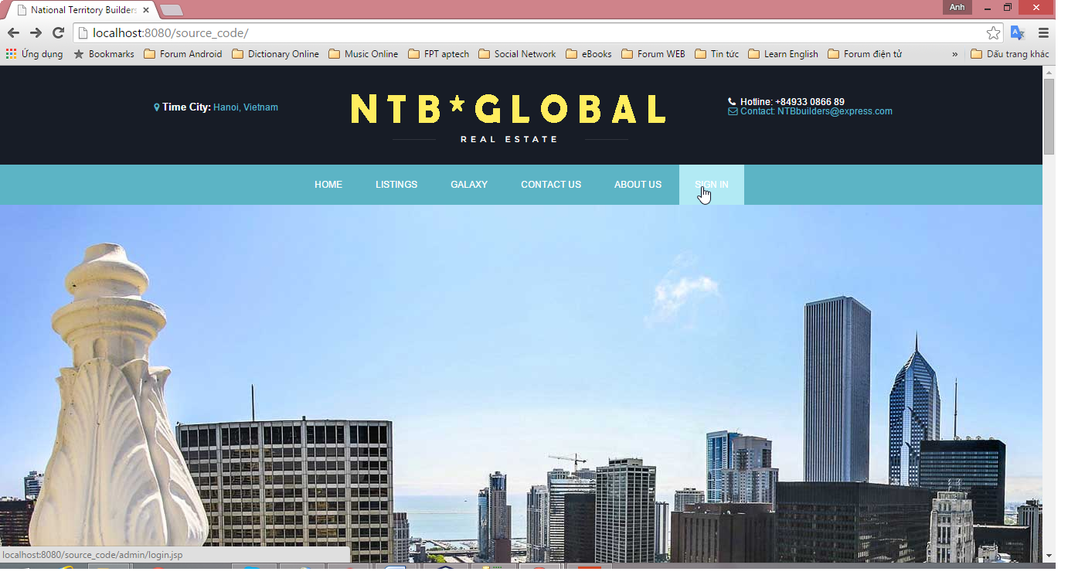

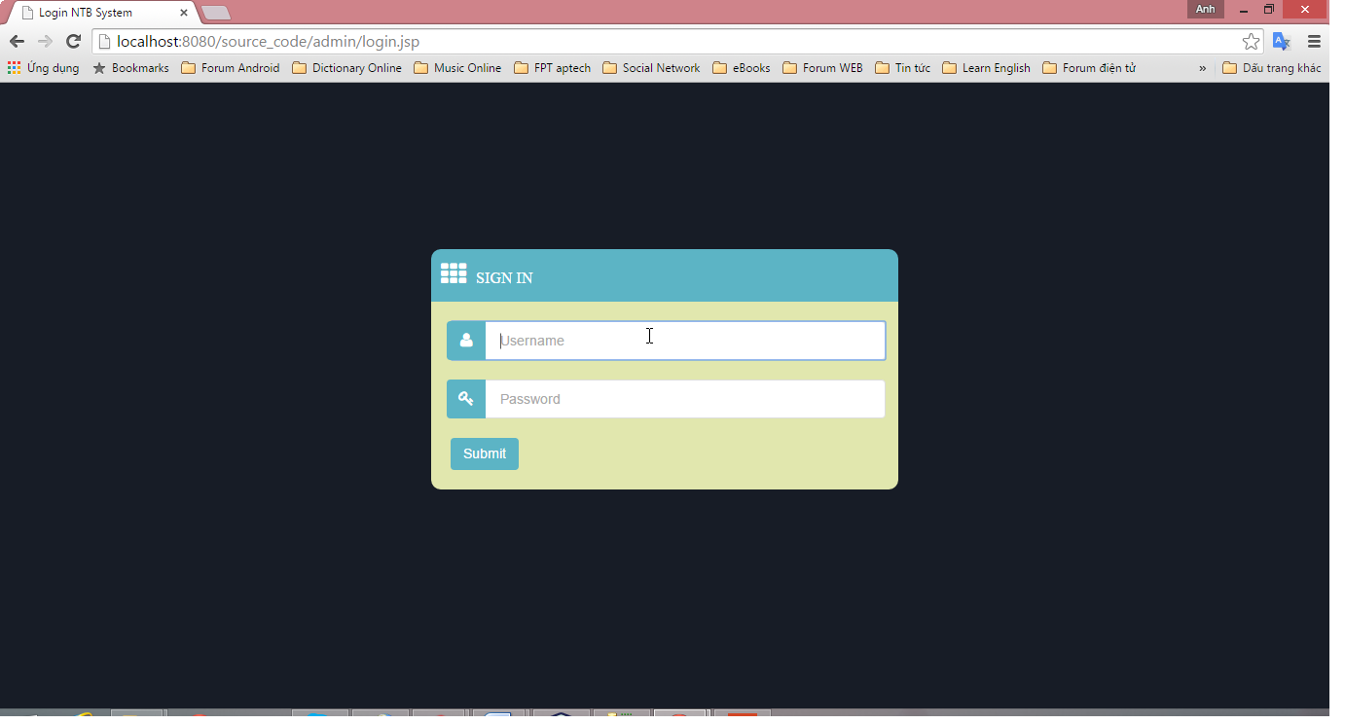

* + Enter account:

Username: admin

Password: 0000

* + After a successful login
* Website creation and management of construction project records:

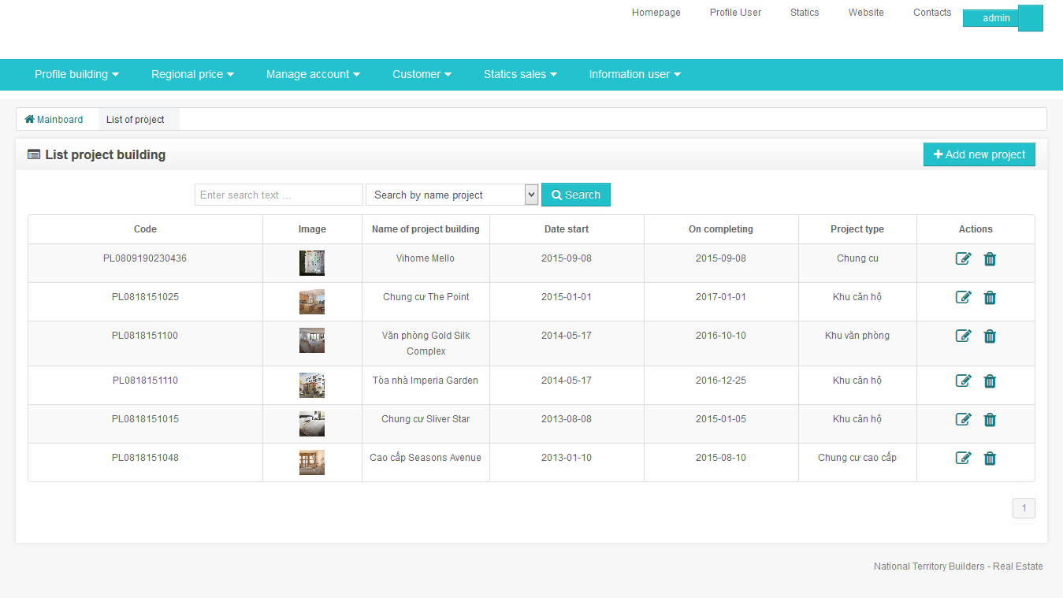

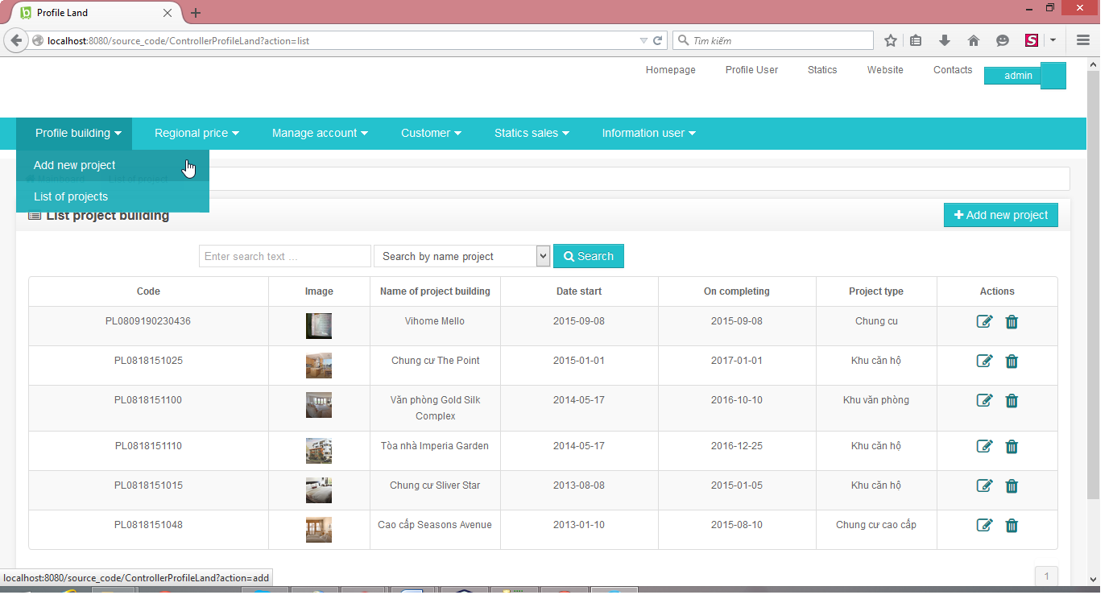

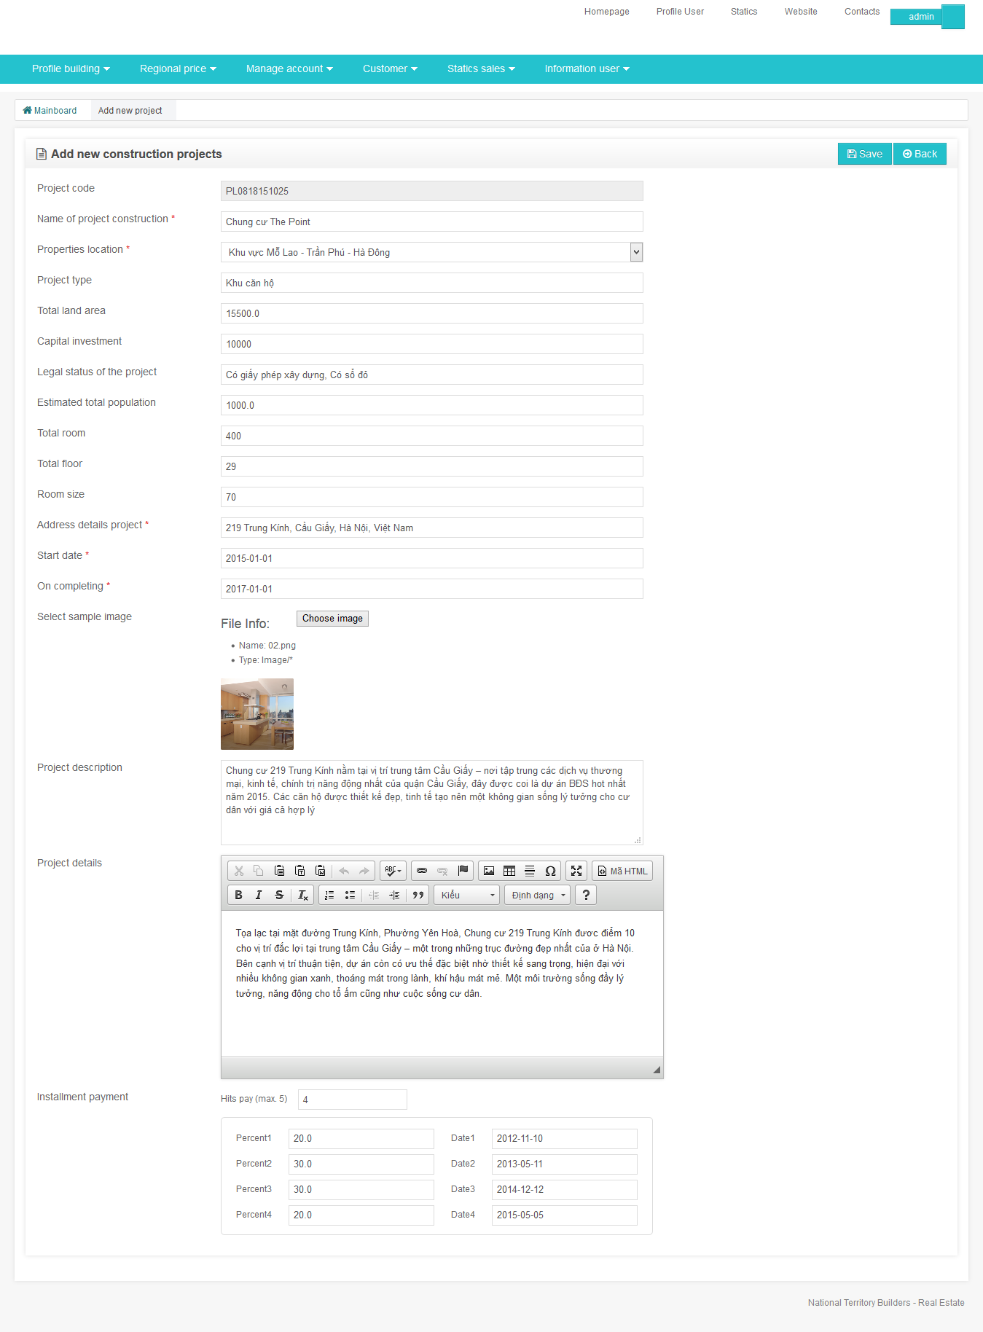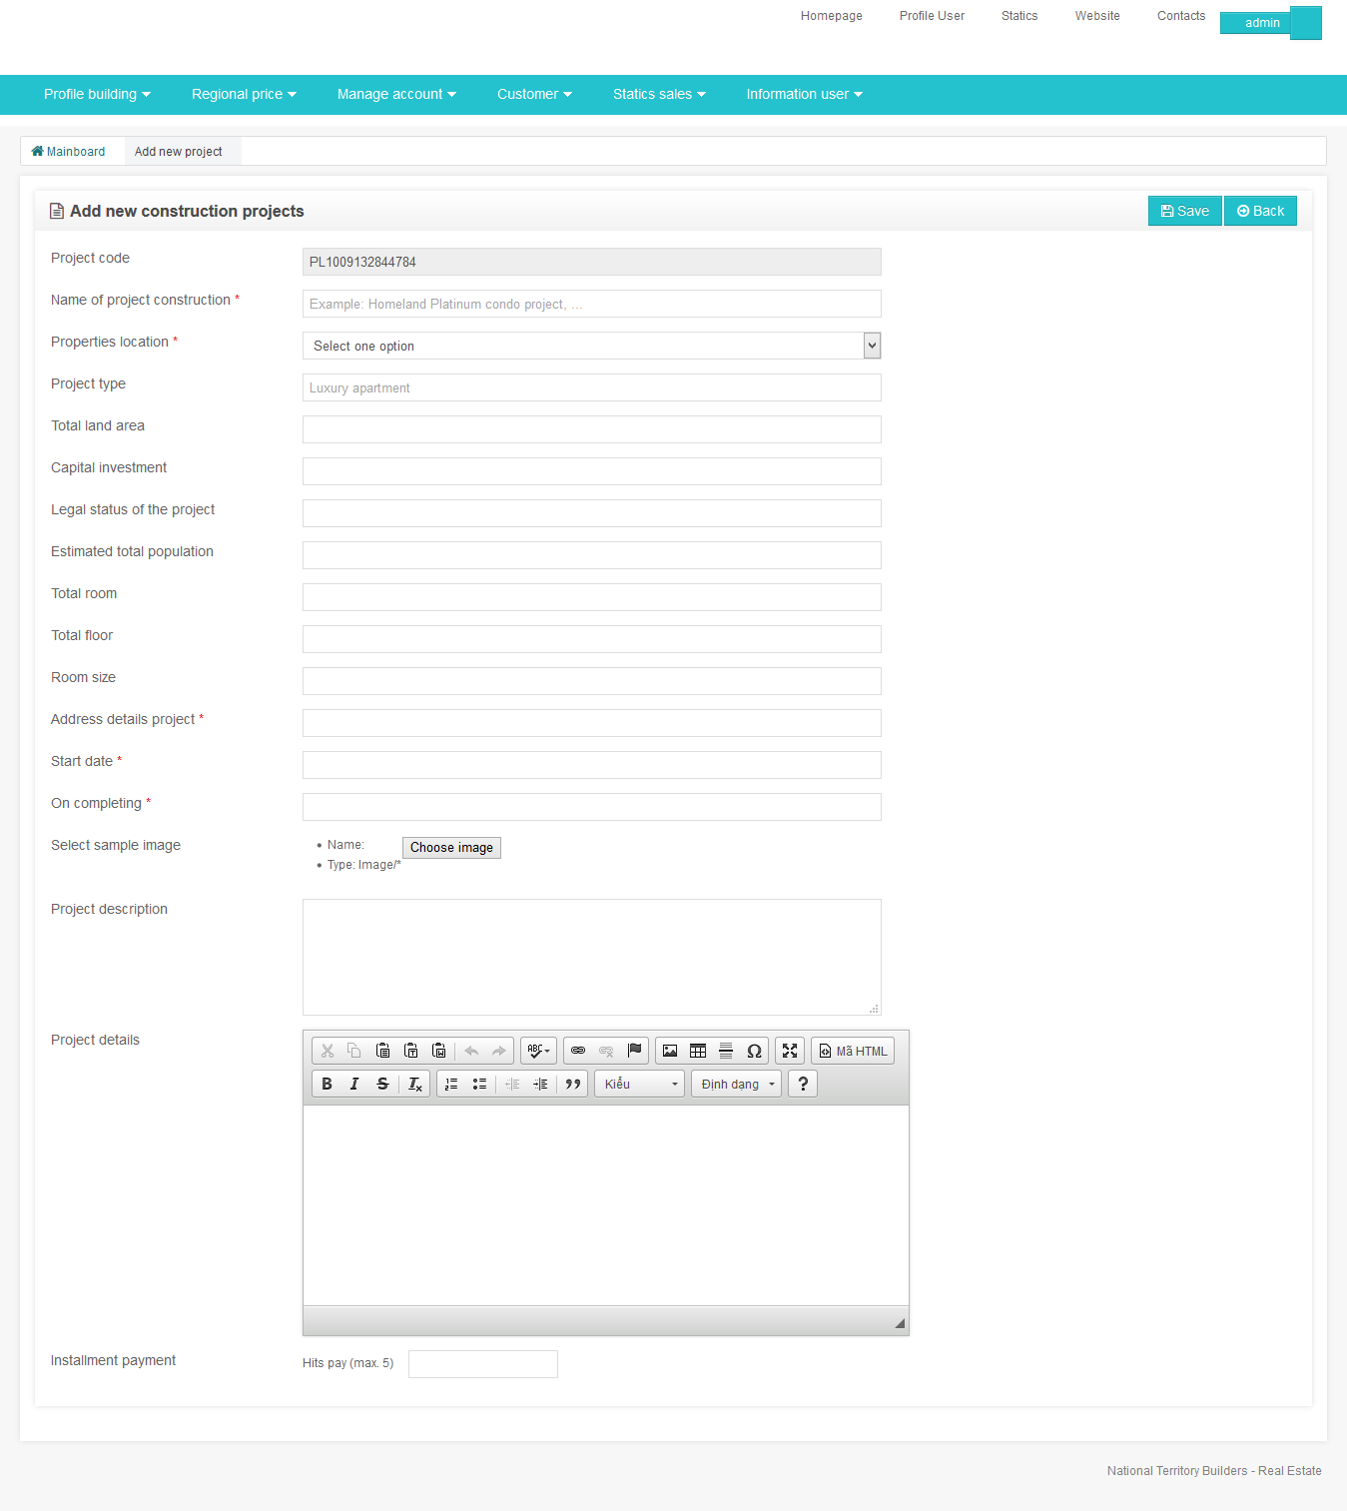

* + Website creation and management of regional price list

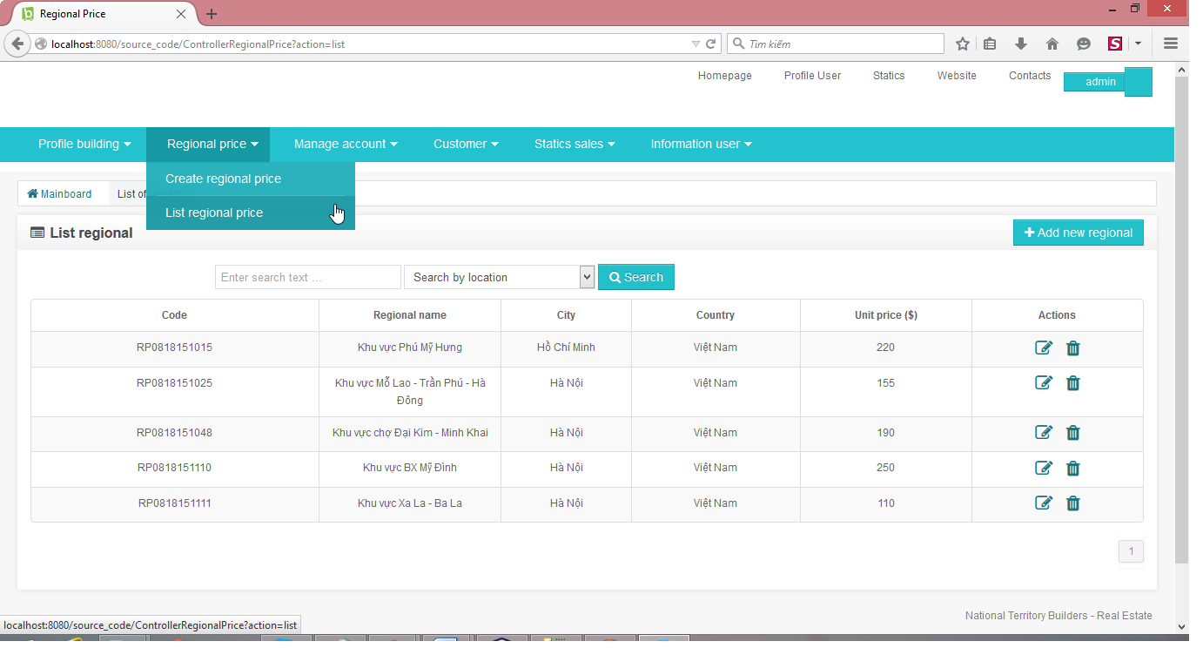

* + Page creating and managing user accounts and admin

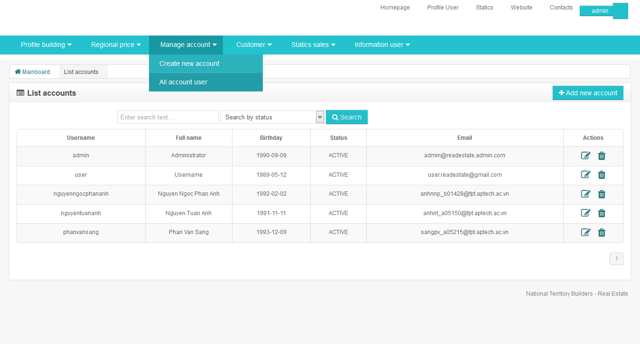

* + Page customer management and billing

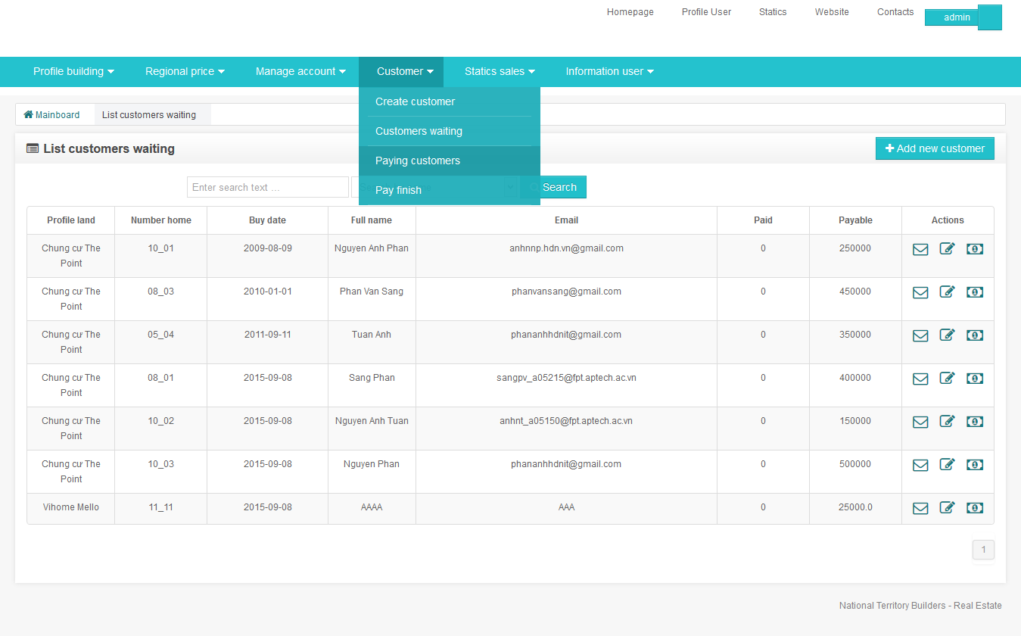

* + Page detailed view of customer payment period

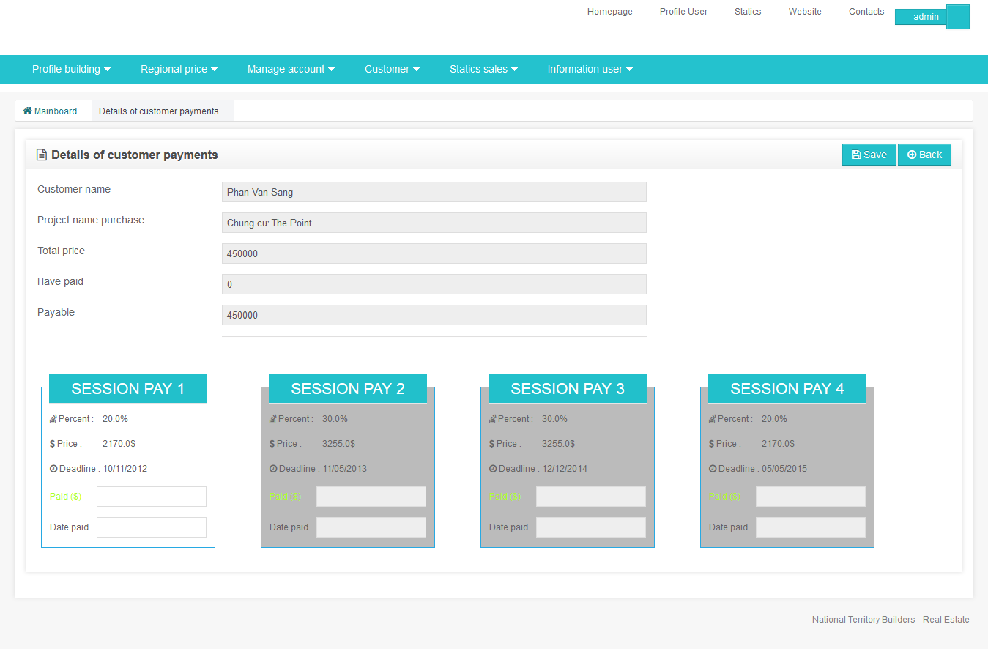

* SIGN IN: Account Customer

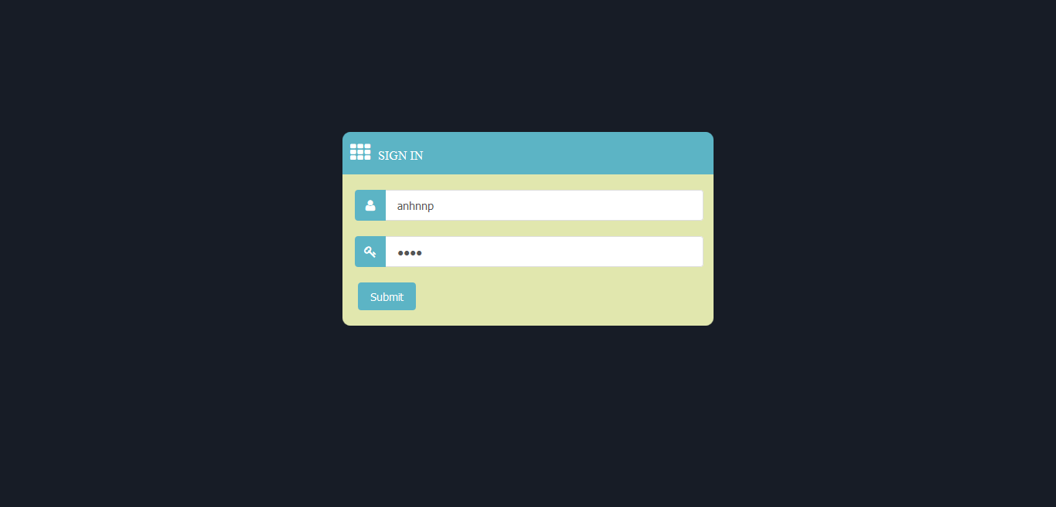

* + Enter account:

Username: anhnnp

Password: 0000

* + After a successful login
  + Automatically display always project page of customers buy and pay
  + This is the sample data after Nguyen Phan Anh customers watched and subscribed the project Condo The Point and is tracking the project progress as well as the payment period

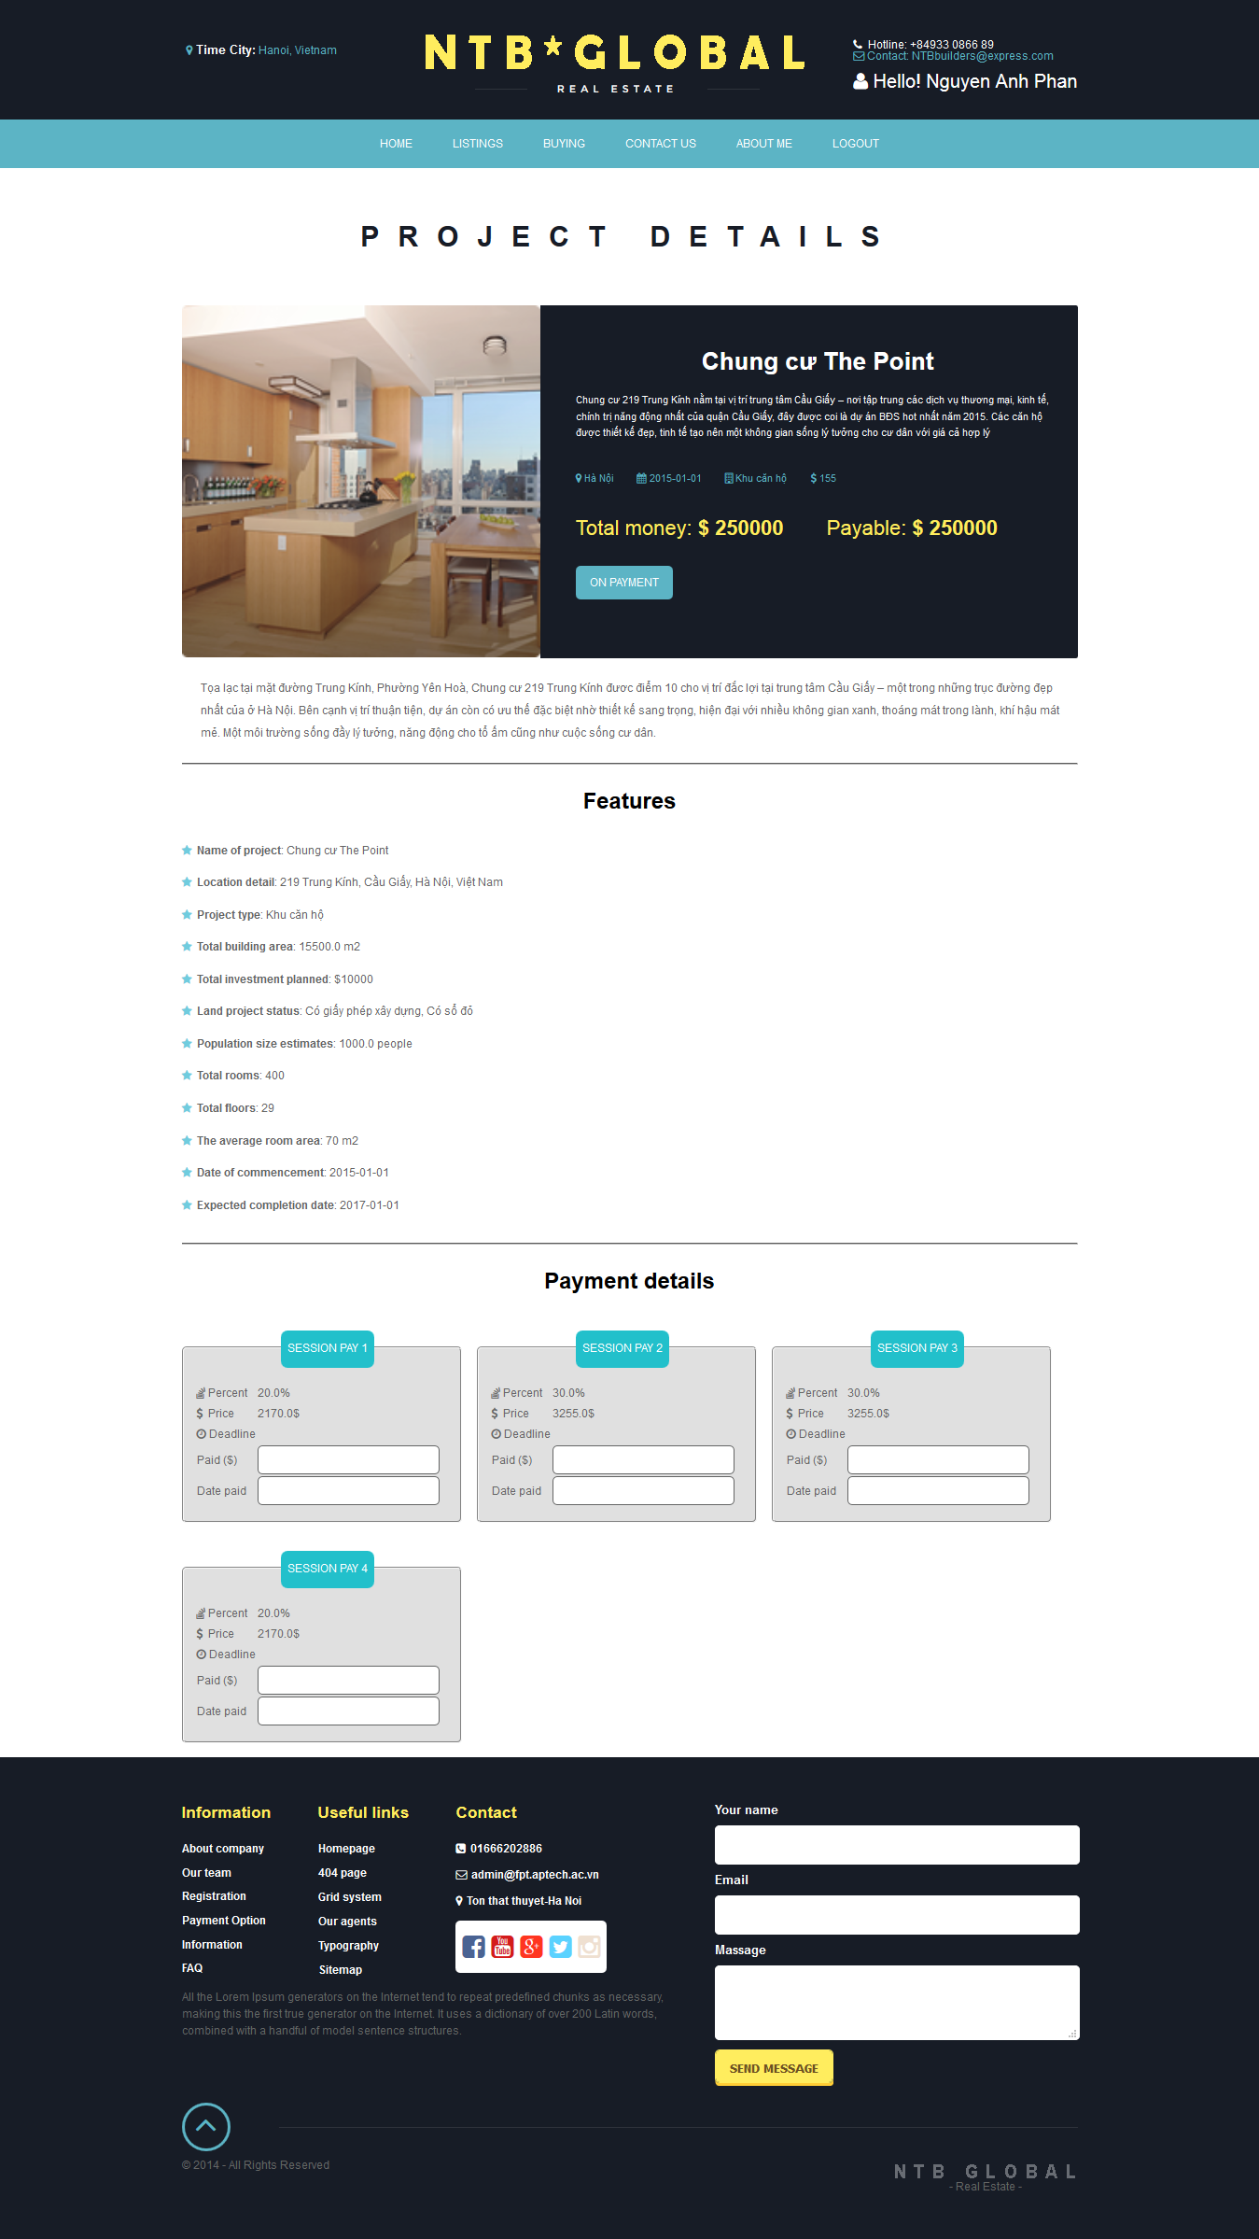

* With any user wants to buy a project, do the following:
  + In view of the project home page under the individual criteria

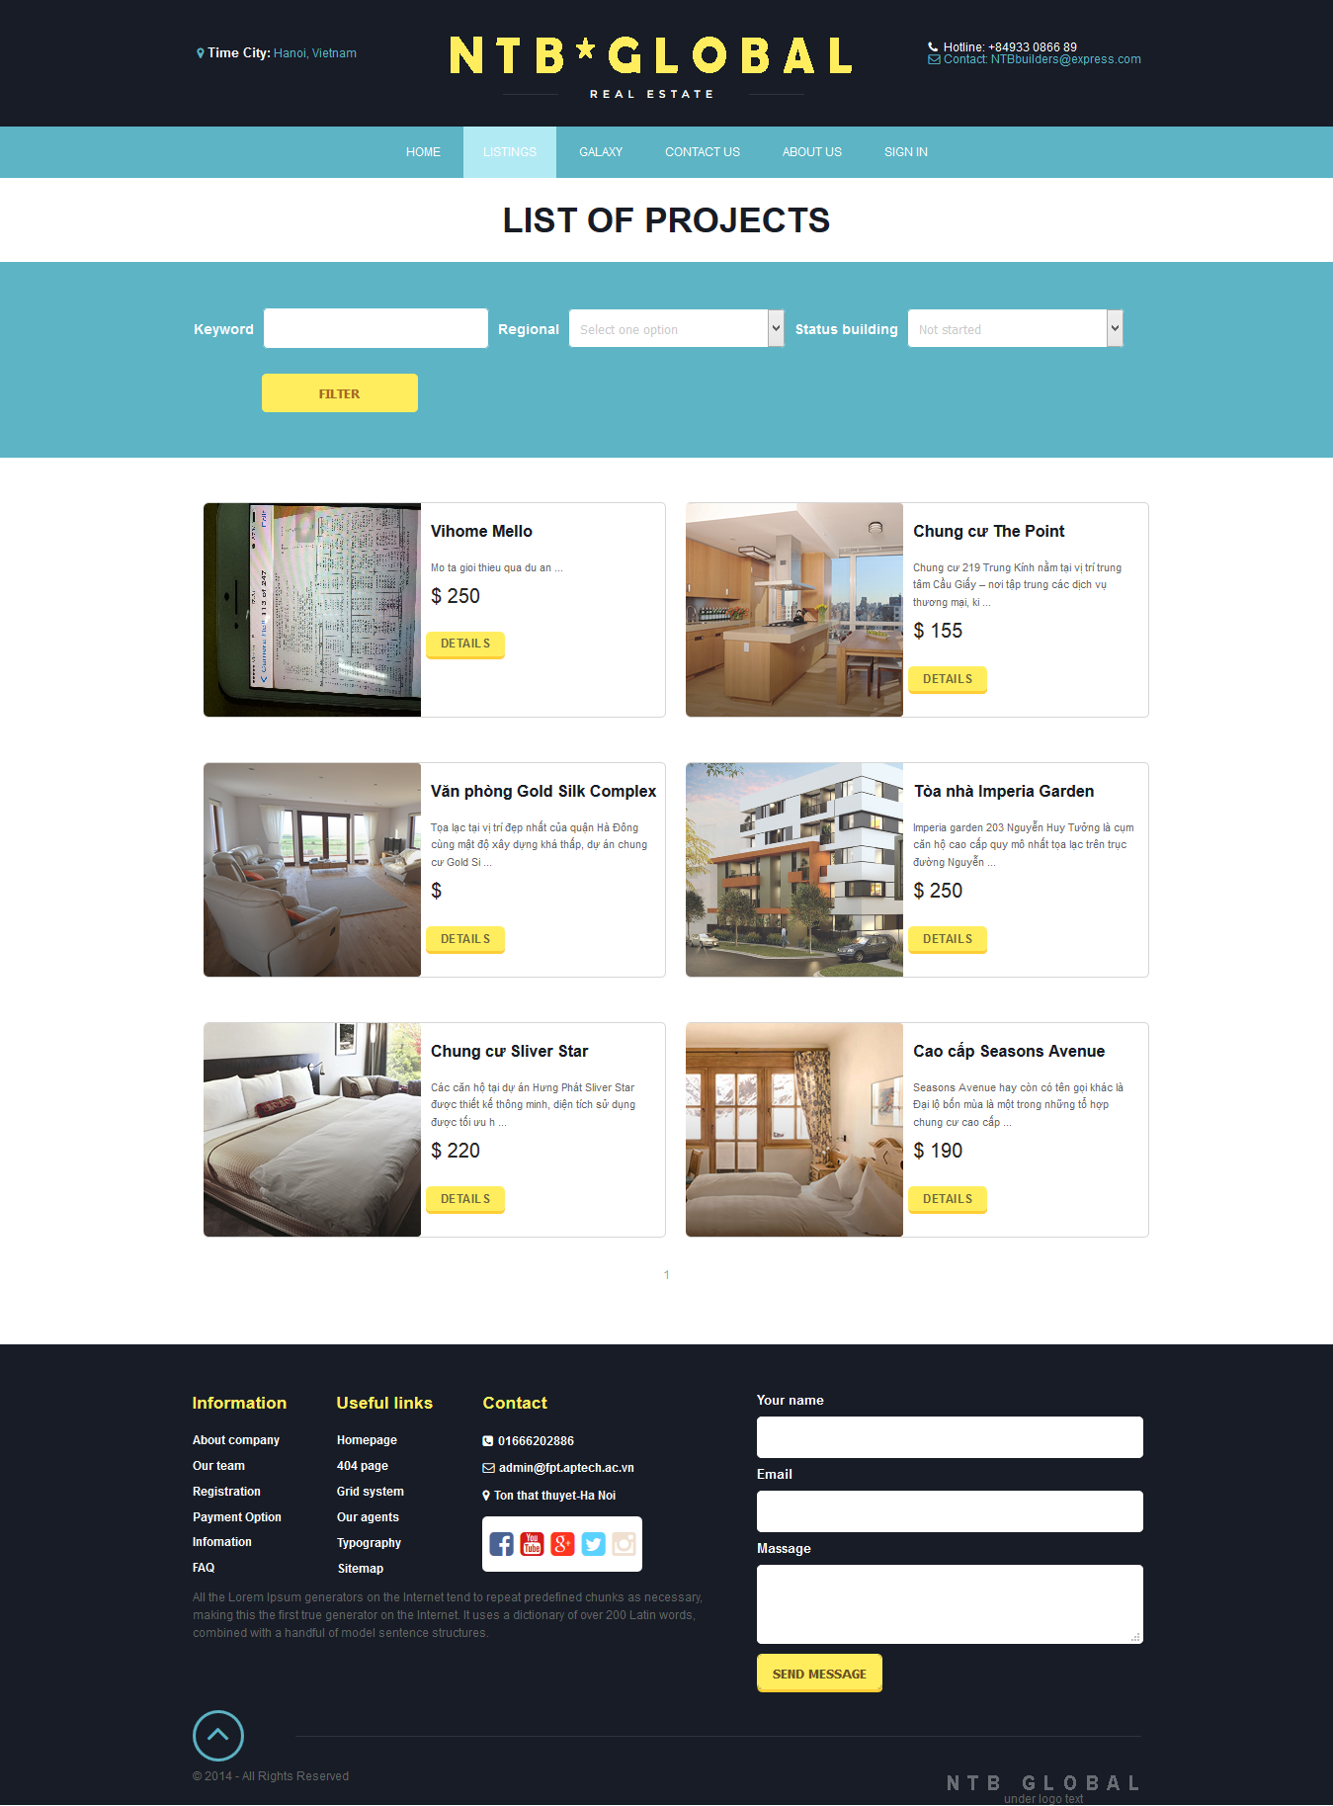

* + See detailed a project

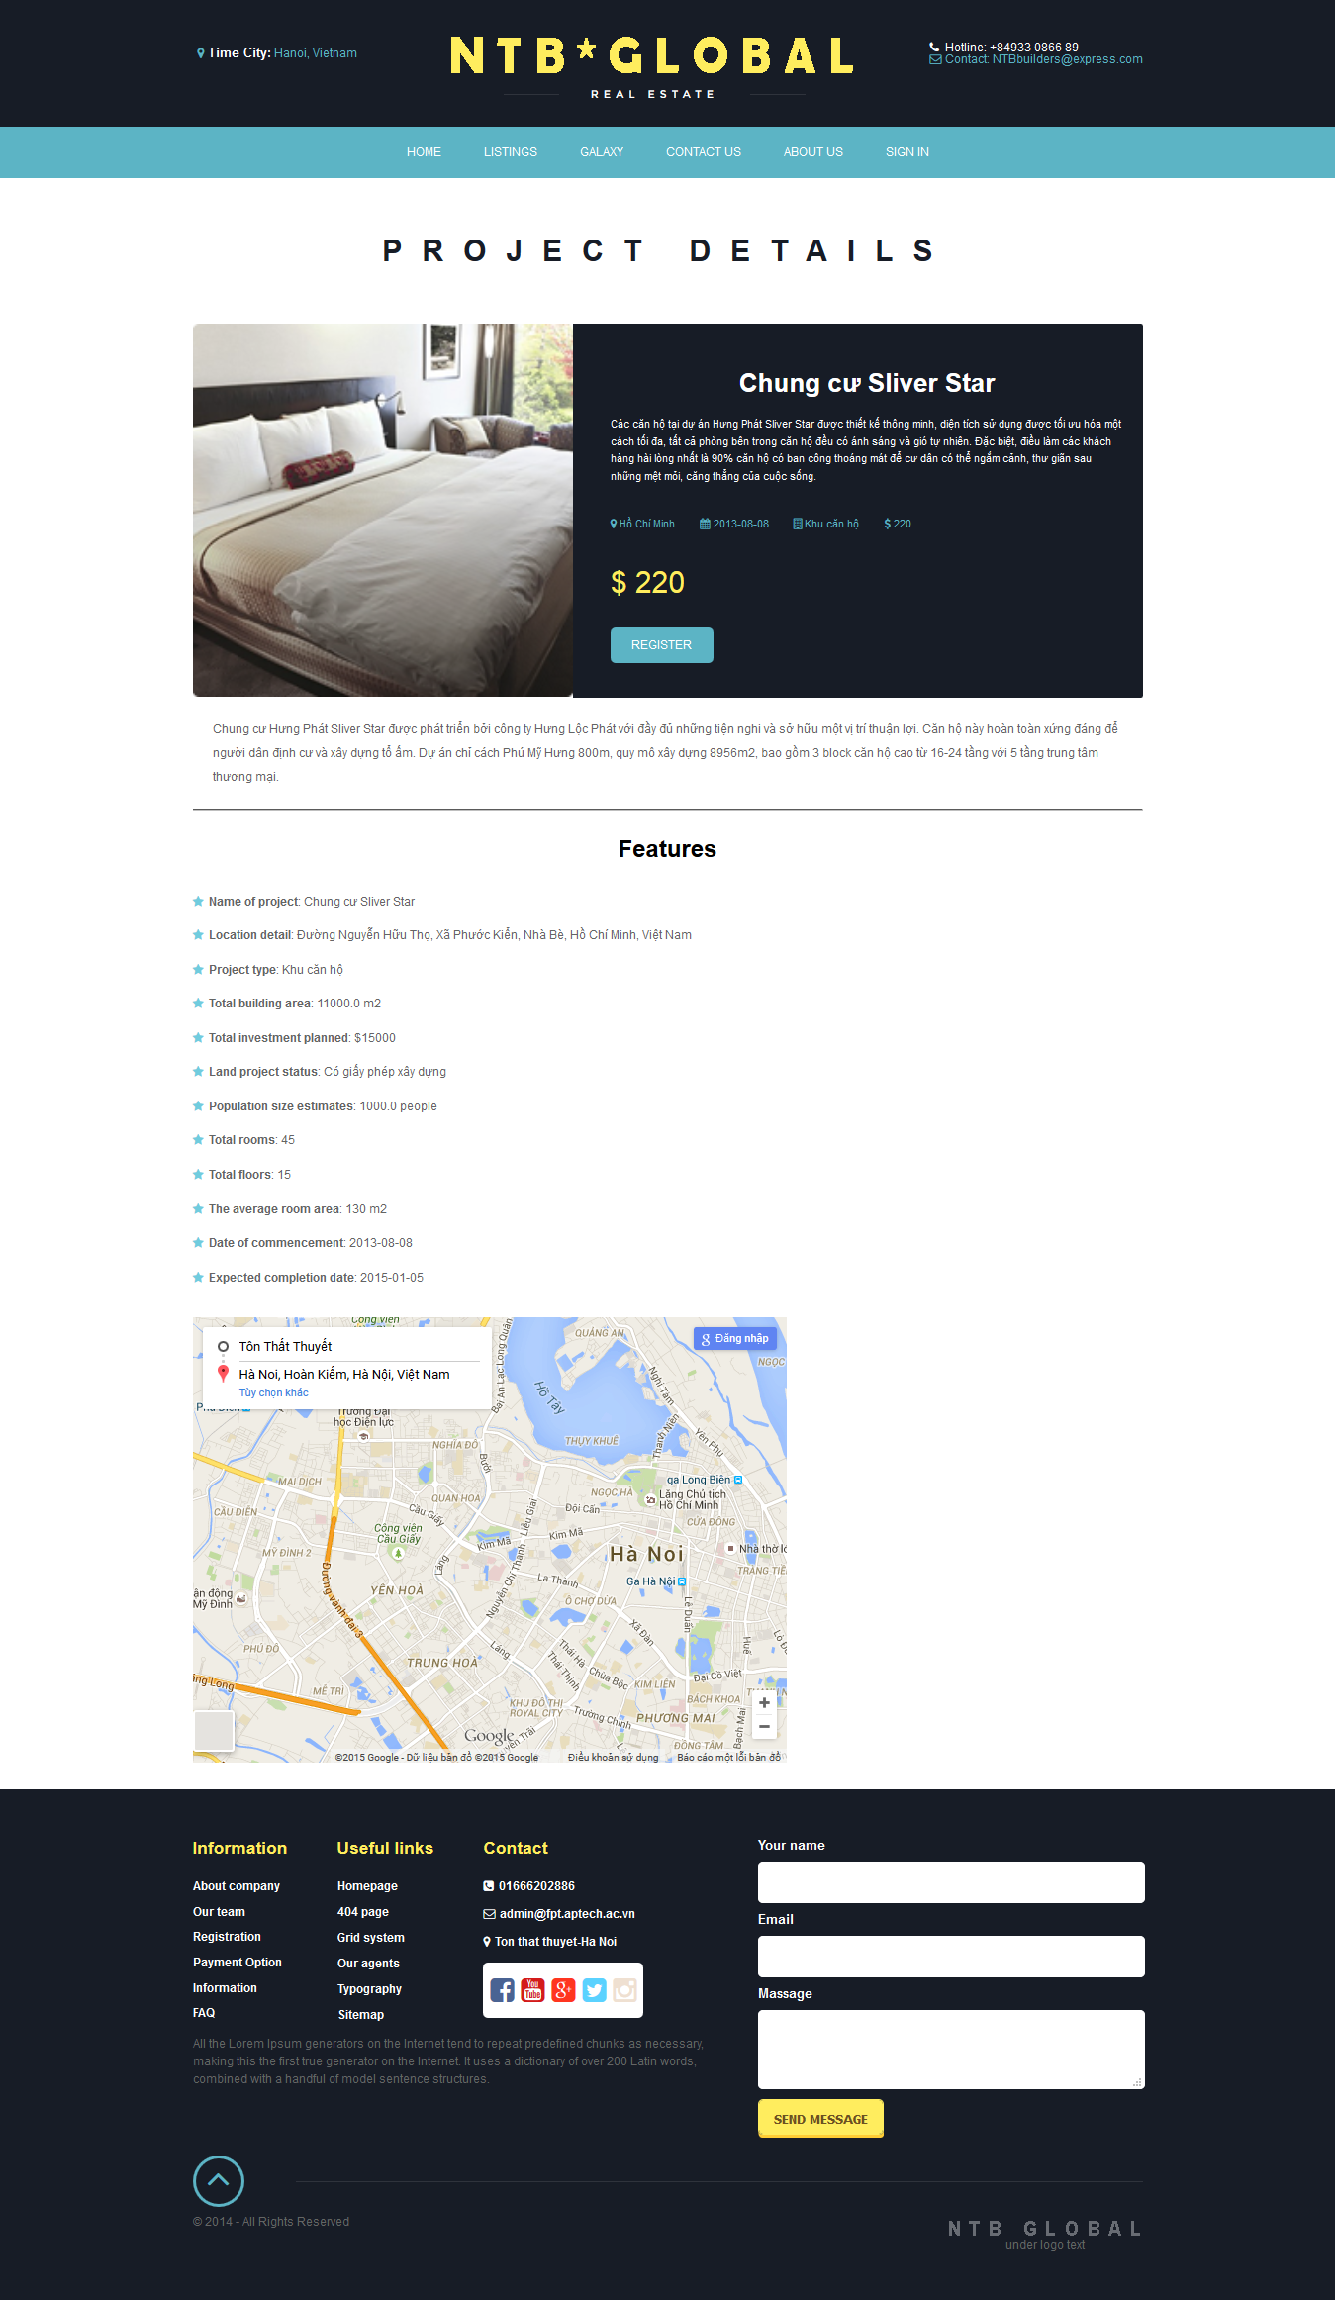

* + Click to register the project and fill out the information as requested to send to management

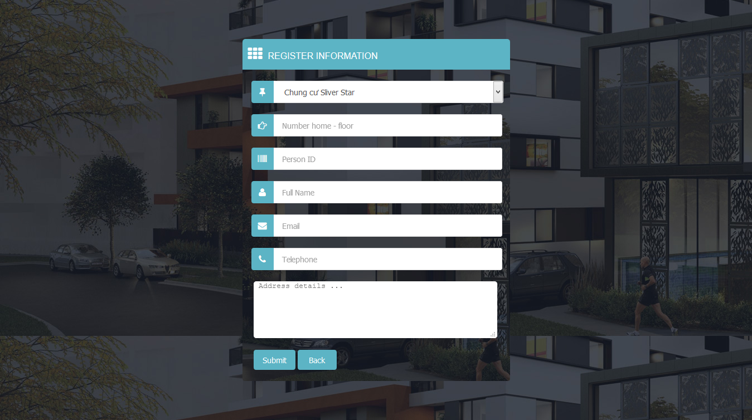

* + End of press submit to send, and forward mail confirmation will be sent to your mail